**Freshco Hypermarket Capstone Project Analysis Report** Est 2021

**Table of Contents**

1. Executive Summary
2. Order Level Analysis
3. Completion Rate Analysis
4. Customer Level Analysis
5. Delivery Analysis
6. Conclusion
7. Recommendations
8. **Executive Summary**

Freshco Hypermarket, situated in HSR, Bangalore, has established itself as a prominent supermarket in the region, catering to a wide range of customers. In response to evolving customer needs and to enhance convenience, Freshco introduced a home delivery service in the year 2021. Key observations include significant variations in delivery charges and completion rates based on time slots, as well as identifying areas with high order volumes.

1. **Order Level Analysis**
2. **Order Time Slots Insights:**

Peak order activity is noted during afternoons consisting of 25.95% of Orders, with limited late-night orders consisting only 6.9% of Orders.

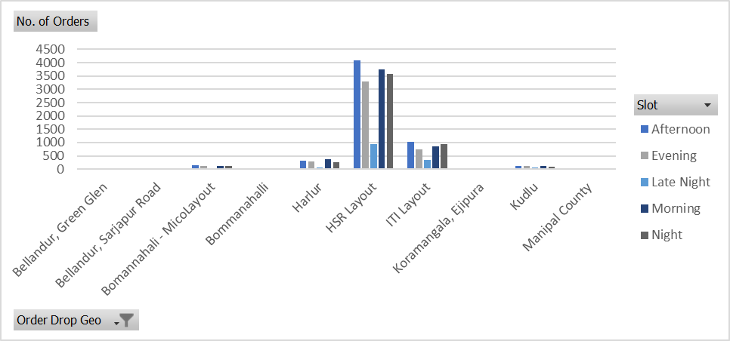

1. **High-Order Areas (Above 500):**

Five areas account for nearly 95% of total orders, led by HSR Layout.

1. HSR Layout (68.6%)
2. ITI Layout (17.28%)
3. Harlur (5.73%)
4. Bomannahali – MicoLayout (2.41%)
5. Kudlu (2.26%)
6. **Monthly Increase in Orders:**

These 3 areas were having Highest Monthly Increase in Orders.

1. HSR Layout
2. Harlur
3. ITI Layout

These areas exhibit significant monthly order growth, especially in September.

1. **Seasonal Order Trends:**

Seasonal order trends show a decline in May and a surge in September.

1. **Delivery Charges and Discounts:**
2. During the months of January to April, late-night deliveries incur the highest delivery charges (>15%).
3. August showcases the peak discount rate (>20%) for all slots except late night (12%).
4. The period from May to September witnesses a reduction in delivery charges alongside an increase in discount rates.
5. Late-night slots feature comparatively lower discount rates.
6. An intriguing inverse relationship is observed between the sum of products and discount rates.
7. Discounts % increase as a Delivery Charges % decreasing (inverse relationship)

**Insights:**

**The analysis suggests that the relationship between delivery charges and discount rates is dynamic and requires strategic alignment. The report highlights those areas with high volume, such as HSR Layout and Harlur, show promise for targeted promotional campaigns.**

**3. Completion Rate Analysis**

1. **The overall completion rate is an impressive 99.55%.**
2. **Low CR Time Slots:**

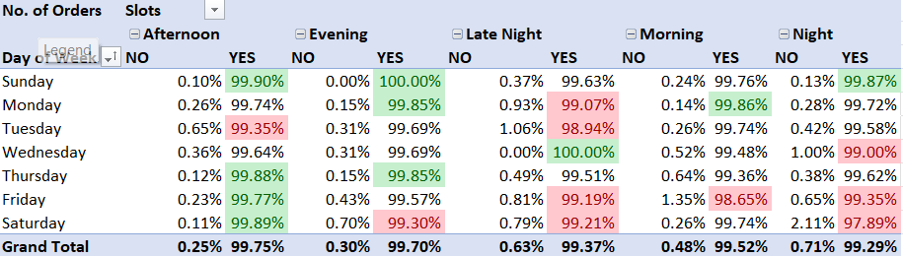

Completion rates are slightly lower during night and late-night slots.

1. **Days with Lowest CR:**

Saturdays and Fridays experience the lowest completion rates., with the late-night slot on Saturday registering a CR of 97.89%.

1. **Certain areas record completion rates below 90%.**
2. Bellandur, ETV
3. Cox Town
4. Domlur, EGL
5. Indira Nagar
6. Marathahalli
7. Vivek Nagar
8. Whitefield (0%)
9. **CR vs. Order/Product Quantity:**
10. Completion rates show a negative correlation with increasing order quantities.
11. Conversely, completion rates demonstrate a positive relationship with higher product quantities.

**Insights:**

**The relationship between completion rates and order/product quantities is dynamic and varies based on time slots and geographical areas. This highlights operational efficiency challenges during peak periods. Targeted strategies for improvement are necessary to address these challenges.**

**4. Customer Level Analysis**

1. **CR by Category/Source:**

Customers Acquires through Organic Sources exhibit the highest completion rates.

1. **High LTV Customer:**

APQ2413449 emerges as the customer with the highest Lifetime Value (LTV), amounting to 62277.

1. **Aggregated LTV Insights:**

Snapchat records the highest aggregated LTV, but a decline is observed over time.

1. **Trend LTV:**

There is a gradual decline from January to September.

1. **Average Revenue Insights:**

Average revenue from Snapchat and Google customers decreases from January to September.

1. **Product Quantity, Discount, and Delivery:**
2. Increasing product quantities align with rising discount rates and decreasing delivery charges.
3. Products with the highest discount rates tend to exhibit positive ratings, while those with elevated delivery charges lack ratings or receive lower ratings.

**Insights:**

**It’s important to prioritize retaining high LTV customers and elevating overall customer satisfaction. The decreasing aggregated LTV and average revenue over the months could indicate potential customer attrition or decreased engagement. It’s important to identify the root cause of these trends and develop effective strategies to address them.**

**5. Delivery Level Analysis**

1. **Delivery Time Insights:**

* May records the longest average delivery time, with two outliers due to single deliveries.
* Notably high delivery times in certain areas include (Outliers)

1. Brookfield (1 hr 31 min 14 sec)
2. Mahadevapura (2 hr 26 min 40 sec)

Conversely, areas with quick deliveries encompass:

1. Cox Town (3 min 11 sec)
2. Whitefield (1 min 4 sec)
3. **Seasonal Delivery Trends:**

* May demonstrate elevated delivery times, particularly over weekends.
* In contrast, September, July, and February showcase optimal delivery times.

1. **Late Night Deliveries:**

* The late-night slot records remarkably short average delivery times (17 min 30 sec).
* Late-night deliveries correspondingly incur higher delivery charges.

1. **Delivery Charges and Time Slots:**

* Single delivery areas bear the highest delivery charges.
* Delivery charges exhibit equitable distribution across areas with 3-4 time slots.
* The average delivery time consistently stands at approximately 25 minutes.

**Insights:**

**It seems that seasonal fluctuations in delivery times highlight the need for resource optimization during peak periods. Late-night deliveries emerge as an opportunity for cost-saving measures while maintaining efficient service.**

**6. Conclusion.**

Based on analysis, it seems that the completion rates, delivery charges, and customer engagement are heavily influenced by the time slots, geographic regions, and product quantities. The analysis also highlights the seasonal trends and the intricate connection between delivery charges and discount rates.

**7. Recommendations.**

Based on the analysis, we recommend implementing strategies to address regions with low completion rates, fine-tuning delivery charges for late-night slots, and investigating methods to balance the relationship between product quantities, discount rates, and delivery charges.